URBAN RUNOFF:
DESIGN A SCHOOL STORMWATER MANAGEMENT PLAN

Adapted for Nature Works Everywhere from the lesson by by Sara Toas of the Ecology Center; featured in TNC’s LEAF Anthology

Subject Area: Biology, Environmental Science

Grade Levels: 9-12
Time:
- Part 1: One to two 45-minute class periods
- Part 2: Two 45-minute class periods, with more time needed for optional activities and research

Essential Question:
- How can we use green infrastructure solutions to better manage stormwater runoff on school grounds?

Purpose and Overview:
Large quantities of rainfall can have enormous consequences in cities, a fact that was reinforced tragically during and after superstorm Sandy in 2012. As damaged cities repair themselves, it is more important than ever to recognize the significance of innovation in these redesign efforts. Large scale storms aren’t the only events that can wreak havoc on an urban environment, even a typical summer storm can impact an urban area in ways that aren’t immediately obvious. For example, urban runoff can contain pollutants that are picked up as rainwater flows over urban surfaces. These pollutants eventually end up in our waterways and can have significant effects on the ecosystem.

Whether a city is rebuilding after a devastating storm or simply looking to revitalize and improve, working with nature rather than against it is a key part of the process of redesigning our cities to be more resilient and sustainable. This lesson introduces students to a variety of nature-based design ideas and asks them to consider which one would be best suited to dealing with urban runoff on their school grounds. For more information on nature-based solutions and green infrastructure, explore the article Accessing Urban Environmental Education Opportunities via Green Infrastructure found here: http://www.thenatureofcities.com/2016/07/03/accessing-urban-environmental-education-opportunities-via-green-infrastructure/.

Nature Works Everywhere Themes:
Stormwater runoff in urban areas can contain pollutants that contaminate waterways. By using green infrastructure, we can harness the power of nature to filter stormwater and keep natural bodies of water clean for the organisms that depend on them.

Objectives:
The student will…
- Learn about and describe the problem of urban runoff.
- Identify opportunities to store, route, and filter stormwater.
- Create an alternative stormwater management plan for their school.
Materials and Resources:
- Umbrellas, raincoats or trash bags as improvised raincoats
- Copies of a map of the school grounds (or maps that depict sections of the grounds), one per pair of students
- Copies of the student handouts for Urban Runoff Part 1 and Part 2: https://www.natureworkseverywhere.org/resources/urban-runoff/
- Clipboards
- Page protectors (optional) to keep map dry
- Sharpies or Vis-à-vis pens
- Sustainable Cities video by Nature Works Everywhere https://vimeo.com/155849692
- Solving Stormwater by The Nature Conservancy in Washington https://www.youtube.com/watch?v=1JDsFJJJHSY
Next Generation Science Standards:
Disciplinary Core Ideas:
- LS2.C: Ecosystem Dynamics, Functioning, and Resilience
- LS4.D: Biodiversity and Humans
- ESS3.C Human Impacts on Earth Systems
- ETS1.B: Developing Possible Solutions

Crosscutting Concepts:
- Cause and Effect
- Stability and Change

Science and Engineering Practices:
- Analyzing and interpreting data
- Constructing explanations and designing solutions
- Engaging in argument from evidence

Performance Expectations:
- HS-LS2-7 Design, evaluate, and refine a solution for reducing the impacts of human activities on the environment and biodiversity.
- HS-ESS3-4 Evaluate or refine a technological solution that reduces impacts of human activities on natural systems.

Common Core Standards (Grades 9/10 and 11/12)
- CCSS.ELA-LITERACY.RST.9-10.4 Determine the meaning of symbols, key terms, and other domain-specific words and phrases as they are used in a specific scientific or technical context relevant to grades 9-10 texts and topics.
- CCSS.ELA-LITERACY.RST.11-12.4 Determine the meaning of symbols, key terms, and other domain-specific words and phrases as they are used in a specific scientific or technical context relevant to grades 11-12 texts and topics.
Background Information:
After a downpour, rainwater courses rapidly over urban landscapes. The rain that falls over a town or city, sliding off roofs, down storm drains and over driveways and streets, is called urban runoff. When rain passes over these surfaces, it picks up pollutants, including sediment, motor oil, pesticides and fertilizers. The water that we use to wash our cars and water our gardens can also contribute to urban runoff. Because of the pollutants it contains, urban runoff can harm the larger bodies of water into which it drains. Conversely, rainwater that falls in a natural habitat runs over the soil surface and slowly percolates through the soil strata (layers), which mechanically and chemically remove contaminants from it before it goes into a water body.
Paved city streets, driveways and parking lots prevent rainwater from falling on the soil, which would filter pollutants with its network of plant roots and soil microbes. Even though lawns and gardens are pervious surfaces, when rain falls on lawns or gardens, the water often picks up chemicals that homeowners apply to keep their lawns green and their gardens weed-free. But pollutants aren’t the only problem. The paved environment of the city guides the pace and volume of the runoff, resulting in erosion, flooding and overflowing storm sewers. These sewers drain enormous amounts of water directly to nearby lakes, streams and bays, without any treatment of contaminants in the runoff. Innovative cities such as Portland, Oregon and Seattle, Washington, are replacing portions of roofs and streets with plants and soil to restore the filtration of stormwater. After soil and plants are added along sidewalks and on roofs, rain follows a slower, cleaner path through the city and onward to rivers, lakes, and oceans.
Below are some examples of green infrastructure solutions that can be used in the urban environment to help manage stormwater runoff using natural solutions. Some examples might work better in your urban environment than others. Some are simple and inexpensive and others are more involved and costly. Additionally, certain landscapes like steep slopes may not be suitable for things like rain gardens and your city may have restrictions that prohibit them in specific areas. Share the following examples of green infrastructure with your students and consider having students do more research on the feasibility of each solution when they develop their plan in Part 2. Your city may have guidelines like those in the “Right Place, Right Project” brochure for the City of Seattle (http://www.700milliongallons.org/wp-content/uploads/2015/08/RightPlaceRightProject.pdf) that help to determine which type of green infrastructure solution is right for your location.
GREEN INFRASTRUCTURE SOLUTIONS FOR STORMWATER

Rain Gardens
Rain gardens collect and filter urban runoff in a shallow, depression before it reaches natural bodies of water. They can absorb up to 30% more runoff than a traditional lawn. They are typically landscaped with native plants that attract pollinators and provide habitat for urban wildlife. For more information on rain gardens and detailed reference materials on how to build one, explore the following resources:

- Rain Garden Handbook for Western Washington
https://fortress.wa.gov/ecy/publications/documents/1310027.pdf
This handbook has some specific information for WA State, but has general information on the design, installation, and maintenance of a rain garden.
- Rain Gardens by the Habitat Network
http://content.yardmap.org/learn/rain-gardens/
General overview of a rain garden and its benefits.
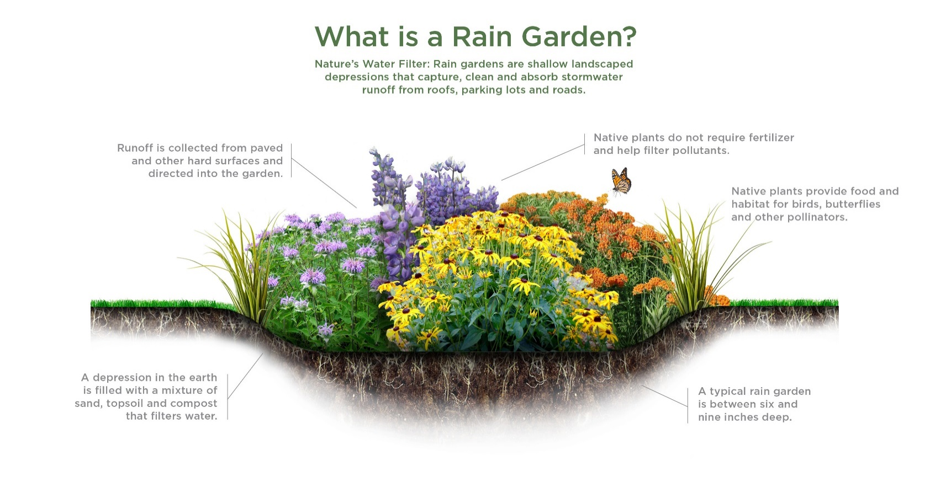
Rain Barrels
Rain barrels can serve multiple purposes. When rain lands on an impervious surface like your rooftop, the rain washes down into gutters, exits the downspouts, and pours out onto the ground. Then it either soaks in or makes its way to the nearest sewer drain and/or body of water. A rain barrel collects rain from a downspout and prevents this from happening. It also allows you to store water for the next time you need it – you can use this harvested water in your garden!
- Adding a Rain Barrel to Your Property by Habitat Network
http://content.yardmap.org/learn/rain-barrel/
Rain barrel basics and examples.

- How to Manage Stormwater: Rain Barrels by Environmental Services for the City of Portland
https://www.portlandoregon.gov/bes/article/378190
Instructions for locating, constructing, and maintaining a rain barrel.

- Rainwater and Water Conservation Incentives by State by HarvestH2o
http://www.harvesth2o.com/incentives.shtml#ri
Every state has different restrictions and regulations surrounding rainwater harvesting. Use this site to check on the rules and incentives in your area.

Stormwater Planter
A stormwater planter is a small garden planter with water-tolerant vegetation. Stormwater planters can be located in a plaza and have storm drain spouts routed underground to them. They can also be located at the edges of roads, below the grade of the curb and street, to store and filter stormwater during a storm. A cut in the curb allows stormwater to drain into the planter.

- Stormwater Planters by Oregon State Extension
http://extension.oregonstate.edu/stormwater/sites/default/files/Planters_0.pdf
A detailed description of stormwater planter function and construction.
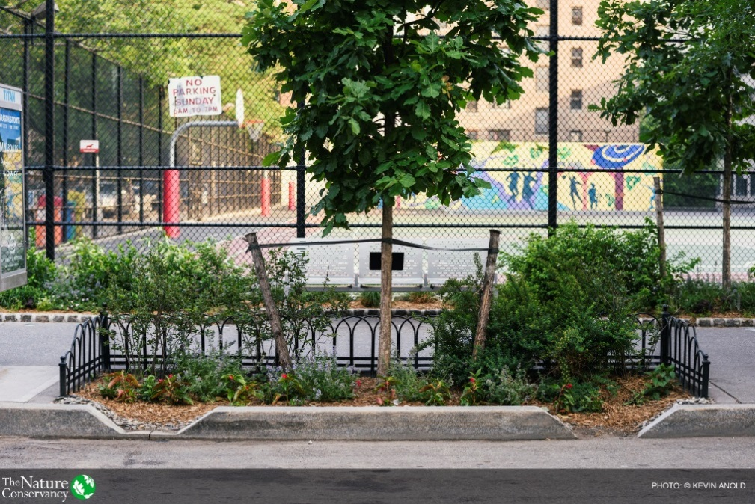

Bioswale
Bioswales are designed to handle a large amount of urban runoff from a street or parking lot. A bioswale slows the speed of urban runoff and stores water until it can be filtered by the vegetation and soil in the bioswale. By serving as a temporary storage, a bioswale reduces the volume of runoff during a storm. A bioswale is usually trapezoidal with a flat bottom. Both the sides and the bottom of the trapezoid are planted with water and drought-tolerant plants. The plants must be as tall as the expected depth of stormwater flow. Bioswales are often 200 feet in length and 6 feet in width, but dimensions will vary depending on the site and soil conditions.

- Bioswales for Stormwater Management by Habitat Network
http://content.yardmap.org/learn/bioswales-for-stormwater-management/
General description of bioswale construction and purpose.

Green Roofs
A green roof replaces a standard roof with vegetation and soil and/or gravel over a waterproof membrane. The roof’s soil and vegetation capture rainfall, which either evaporates, transpires, or is slowly filtered and discharged to the stormwater system. Green roofs are designed to support the increased weight of the soil and vegetation. Because plants convert the sun's energy into humidity and soil moisture, green roofs keep houses cooler. Green roofs can help dampen the “urban heat island” effect, which is the increase in temperature in a city caused by the prevalence of dark surface areas that absorb the sun's energy. Green roofs also provide habitat for insects and birds. Green roof plants are low maintenance and suited to live in a shallow soil bed. They are able to tolerate harsh conditions on a rooftop, such as high sun exposure, little to no water and high winds. Sempervivum, Phlox, Aubrieta, Antenaria, Armeria, Sedum are common green roof plant species.

- 10 Great Plants for Your Green, Living Roof by Brian Barth for Inhabitat.com
http://inhabitat.com/top-10-plants-for-a-living-roof/
Information on green roof plants and photo gallery of plant species.

- Green Roofs by Habitat Network
http://content.yardmap.org/learn/green-roof/
General information on green roof design and examples.

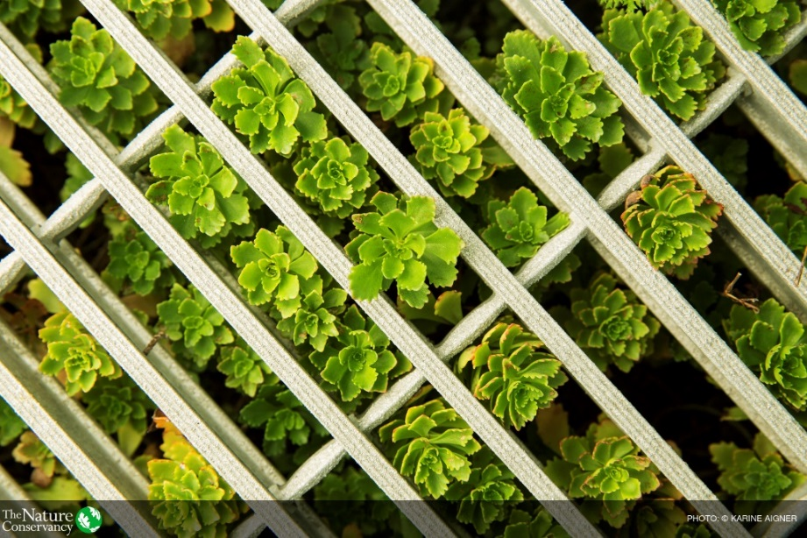
Green roof on the American Society of Landscape Architects in Washington, D.C.
Vocabulary:

Bioswale: a wide, shallow, manmade ditch meant to replace traditional gutters and curbs in parking lots and streets.

Impervious: a surface such as rock or pavement that water cannot penetrate.

Pervious: a porous surface such as mulch or soil through which water can flow.

Urban runoff: water that falls as rain and washes across urban surfaces like streets and rooftops. It often picks up pollutants along the way.

Classroom Activities:

Part 1: LEARN – Discovering Stormwater Runoff on School Grounds

- Before class, prepare paper maps of the school grounds for students to use and photocopy the Urban Runoff Part 1 student handout (https://www.natureworkseverywhere.org/resources/urban-runoff/). If you don’t already have a map of your school grounds, you can map your school on Google Maps and then print the screen. You can put the maps inside a clear page protector to keep them dry outside. Students can use a Sharpie or Vis-à-vis pen to write on the map through the page protector.

- Show the Nature Works Everywhere video Sustainable Cities: Nature-based Solutions in Urban Design (https://vimeo.com/155849692) as an introduction to the problem of urban runoff and the challenges facing cities. The video showcases nature-based solutions and provides inspiration for green infrastructure projects. You can also play the video Solving Stormwater by The Nature Conservancy in Washington (https://www.youtube.com/watch?v=1JDsFJJJHSY) to illustrate the consequences of urban runoff for organisms like salmon in the Pacific Northwest. In the video, scientists investigate how using green infrastructure to filter urban runoff can remove toxic pollution and prevent it from entering bodies of water.

- Conduct a rainy day schoolyard tour with students where students will examine and chart how stormwater flows on school grounds. Assign students to pairs. Choose four or more areas of the school grounds that you would like to explore with your students. Based on the size of your school grounds and the number of students, you can create sections on the map and send student groups to these sections instead of having them survey the whole area. Recommended areas: near downspouts, a parking lot, a driveway, a playing field or a school garden.

- Before going outdoors, have the class generate a list of pollutants they might find outside and create pollutant symbols for each. Have them create a symbol legend that everyone will use for this activity. For example, trash, dog feces, chemicals (pesticides), and oil are examples of possible pollutants - students should determine a symbol for each. They can record the symbols on their handout.
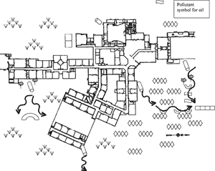
Sample of Final School Grounds Map with Symbols

- Distribute copies of the maps and the Urban Runoff Part 1 student handout. Students can follow the instructions on the handout and complete their maps outside.

- During the next class period, go over the following discussion questions with students. Groups can share their maps with the class if you have a document camera. Students will discuss their stormwater runoff findings. Use the following questions to guide the discussion.

- Does the water flow that you observed end up in one place? More than one place? Where?

- Where does the system of storm drains on your school building channel the stormwater? Does it end up on an impervious or pervious surface?

- Where does stormwater flow in the school parking lot? Does it lead to a garden? Is it routed through a bioswale? Does it run rapidly to a low point in the parking lot?

- If you identified any pollutants what were they and where did they originate?

- From question #10 on the handout “Describe the flow and impact of these pollutants beyond the school to places where they may cause damage.” This is a key question because it allows students to communicate that they understand the broader impact of urban runoff beyond their school. Students MUST be able to identify, and discuss solutions to, the larger scale problem.

- Is your school using stormwater treatment alternatives such as bioswales, stormwater planters or green roofs to store, route and filter stormwater?

- What is one thing you could do to filter stormwater runoff at your location?

- How does stormwater runoff affect the larger community?

Part 2: EXPLORE – Designing a Plan for Stormwater Runoff

- Using their findings from the rainy day mapping, students will design improvements in the way the school slows down, routes and filters its stormwater before it drains into the city stormwater system.

- Pair students with their partners from the rainy day mapping and have them take out their runoff maps.

- Give them a large sheet of paper (butcher paper works well) or have them tape two pieces of recycled 8.5-inch by 11-inch paper together.

- Have students work through the questions on the Urban Runoff Student Handout Part 2 (https://www.natureworkseverywhere.org/resources/urban-runoff/) and identify the areas on the map where they would like to implement a green infrastructure solution. You may wish to go over the green infrastructure solutions described in this lesson plan in more detail before students develop their plan.

- After students have created their plan, have them answer the assessment questions on page 2 of the handout. These will form the basis of their presentation to the class. Per your direction, students may create a PowerPoint or other format when presenting.

- (Optional) You might also have students do a feasibility study to determine if these types of projects are acceptable in your city and to determine the associated costs. Be sure to have them include this information in their presentations. If you have the time and resources to actually implement the projects, these presentations could serve as the initial vetting process for the actual project.

Additional Resources:

- Habitat Network, a joint project of The Cornell Lab of Ornithology and The Nature Conservancy
http://habitat.network
You can use this online tool to map your school grounds and identify areas for improvement. If your students implement any of their projects, the changes can be added to the Habitat Network map, making your school grounds part of a massive citizen science project to map urban habitats. Additionally, the site contains extensive information and examples of habitat improvement projects.
- For more information about using Habitat Network at school, check out the following blog post: http://content.yardmap.org/learn/at-a-school/

