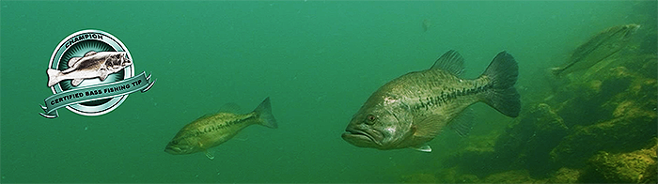

DESIGNING YOUR TOURNAMENT WINNING PLAN

Here’s where your entire class gets to design their own “tournament winning plan” on bass fishing.

STEP 1 - First, explore and research a number of the helpful resource links below on tournament fishing. These links will have your fishing smarts tackle box overflowing.

STEP 2 – Next, divide the class into 3-person bass fishing “teams”

STEP 3 – Each 3-person team should devise their own custom plan, based on their collective research and experience. Each plan should include two main phases: 1) the “homework” and research phase, and 2) the on-the-water investigation (catching bass!)

STEP 4 – Show-N-Brag by sharing your fishing success, lessons learned, and your catch photos or videos. Exchange new things you learned about developing your tournament plan.

- Be Versatile
- Unfamiliar Waters
- Charting Your Catch
- Learning New Lakes
- 10 Tips For Success
- Tournament Strategy
- Prefishing Tournaments
- Pre-Tournament Practice
- Approaching New Water
- Fishing Unfamiliar Lakes
- Understanding Lake Maps
- Solving the Big Water Puzzle
- Fishing Tournaments on Home Waters
- Learn From The Bass Pros
- The Bass University Announces 2015 Class Schedule
- Tournament Preparation Tips
- Fishing Resumes Versus Proposals
- Bass Fishing Pros Prepare For Classic In Various Ways

